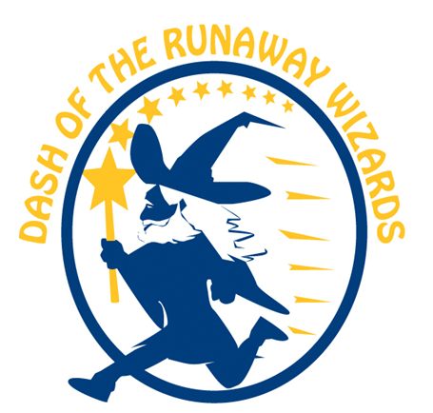

Woodlin Elementary School
Dash of the Runaway Wizards
Fundraising System
For the Dash of the Runaway Wizards this year, we're using a web based fundraising system called Pledgestar that makes it much easier for you to request pledges from your family and friends, and for them to make secure credit card donations online. This platform is new this year and will hopefully address some of the issues that we’ve had in the past with other platforms.

Remember, our Dash of the Runaway Wizards is October 19, so please register now to help our school raise as much as we can for Community Building, Enrichment and Academic Support:

- Go to http://pledgestar.com/woodlin
- Click “Not Registered For This Year’s Event”
- Enter your name and email address, then click “Submit”
- Follow the instructions on-screen to register students

When you finish, the system emails pledge requests to your family and friends, and allows them to make secure credit card donations online. You get notified each time a pledge is made, and you can track your pledge progress online.
Call 1-888-598-7510 if you need help.

